***NAV***

* In NAV, you can check if stock is available, ETA, weight and prices.
* You can search for a sales quote.
* You can search for a sales order.
* You can create a sales order & sales quote direct (only under certain circumstances/certain exceptions)

Clip on NAV icon 

Screen will open to home screen:

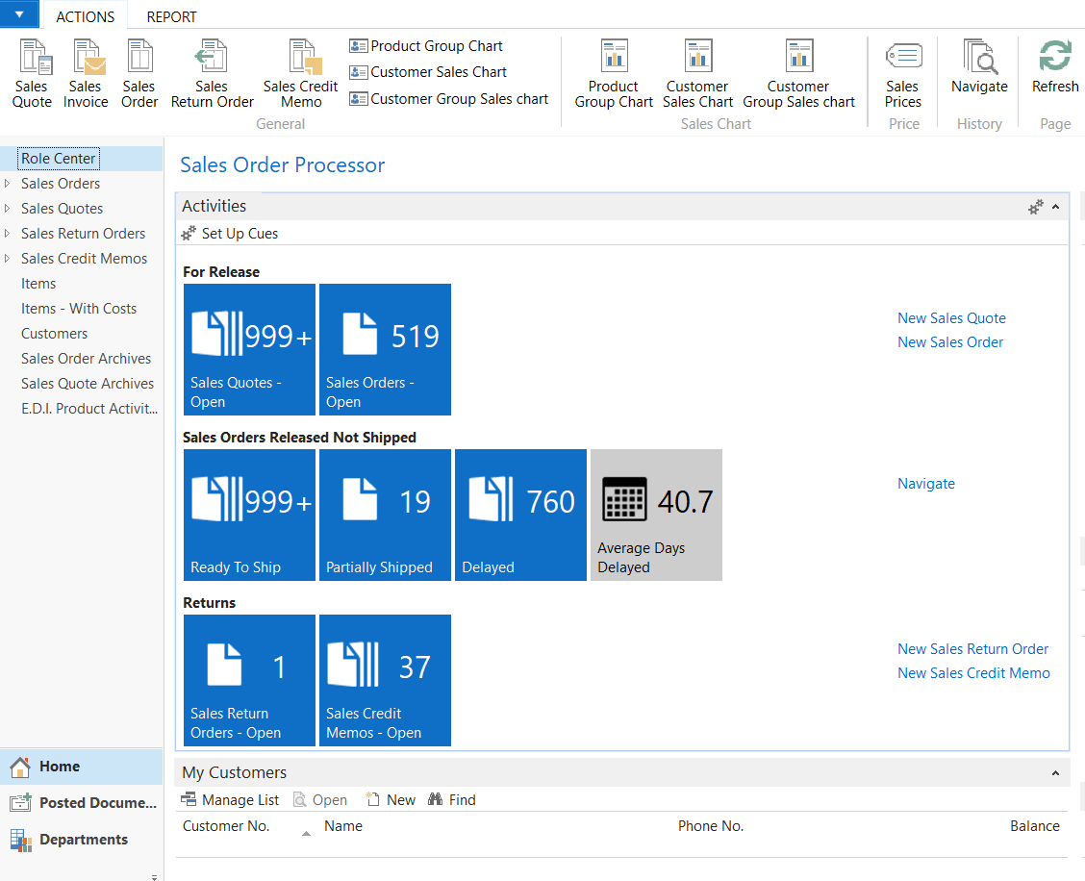

* To check stock, click on Home – Items
* To check a sales quote, click on Home – Sales Quotes
* To check a sales order, click on Home – Sales Orders
* To check on a posted document, click on Posted Documents – Posted Sales Shipments

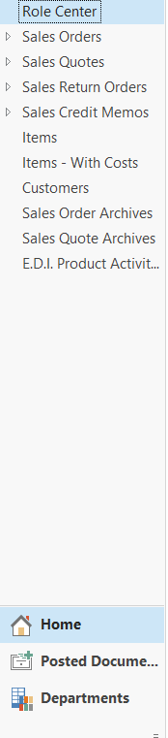

You can search for an item by part # OR by description.





You can check prices by clicking tab Navigate then select Prices.

You only search for price under CUS555.

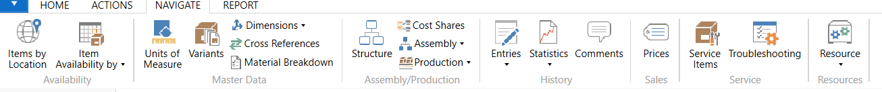

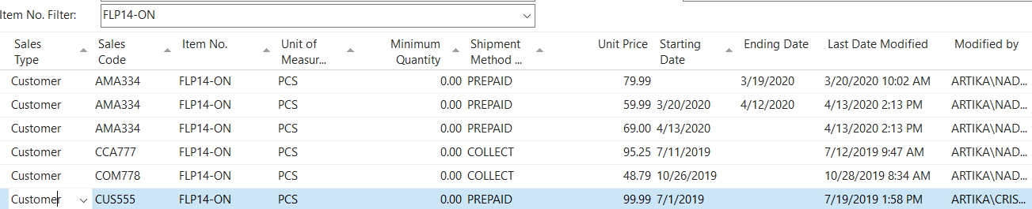

You can verify stock by clicking Navigate tab then select Item Availability by – Location

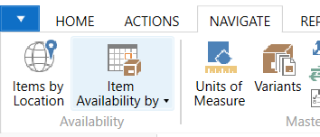

We only have stock if there is a quantity in the ARTIKA FOR LIVING -LACHINE warehouse.

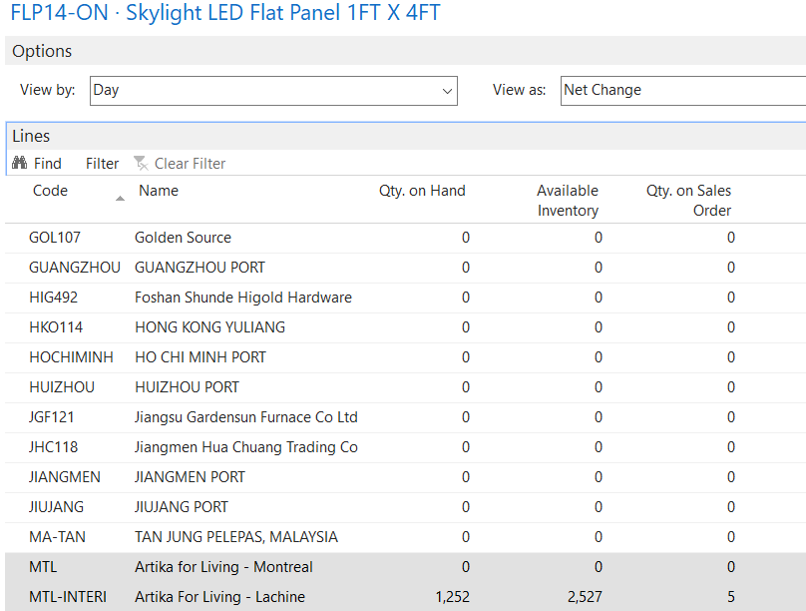

You can check for weight and dimensions of an item by clicking the tab Navigate – Units of Measure.

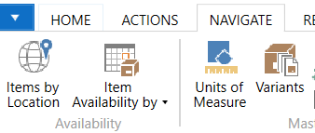

You always read the line PCS for the information of one item:

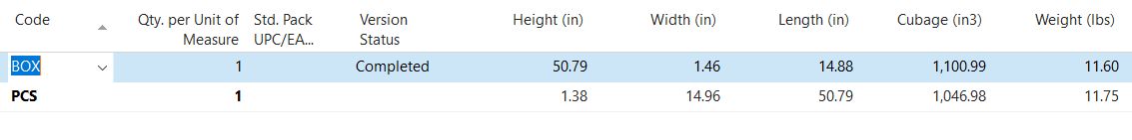

If you are searching for a quote or an order or you need to view one, you click on the appropriate selection.

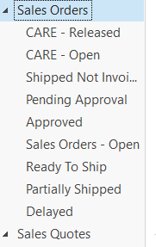

You can search by either quote/SO# OR by Customer name by selection the correct selection in the drop down and by entering either the number provided by the customer or by their name.



Below is the screen in NAV and fields that must be filled out for a sales quote/sales order.

General & Shipping: If done properly in Salesforce, all the fields will populate automatically.

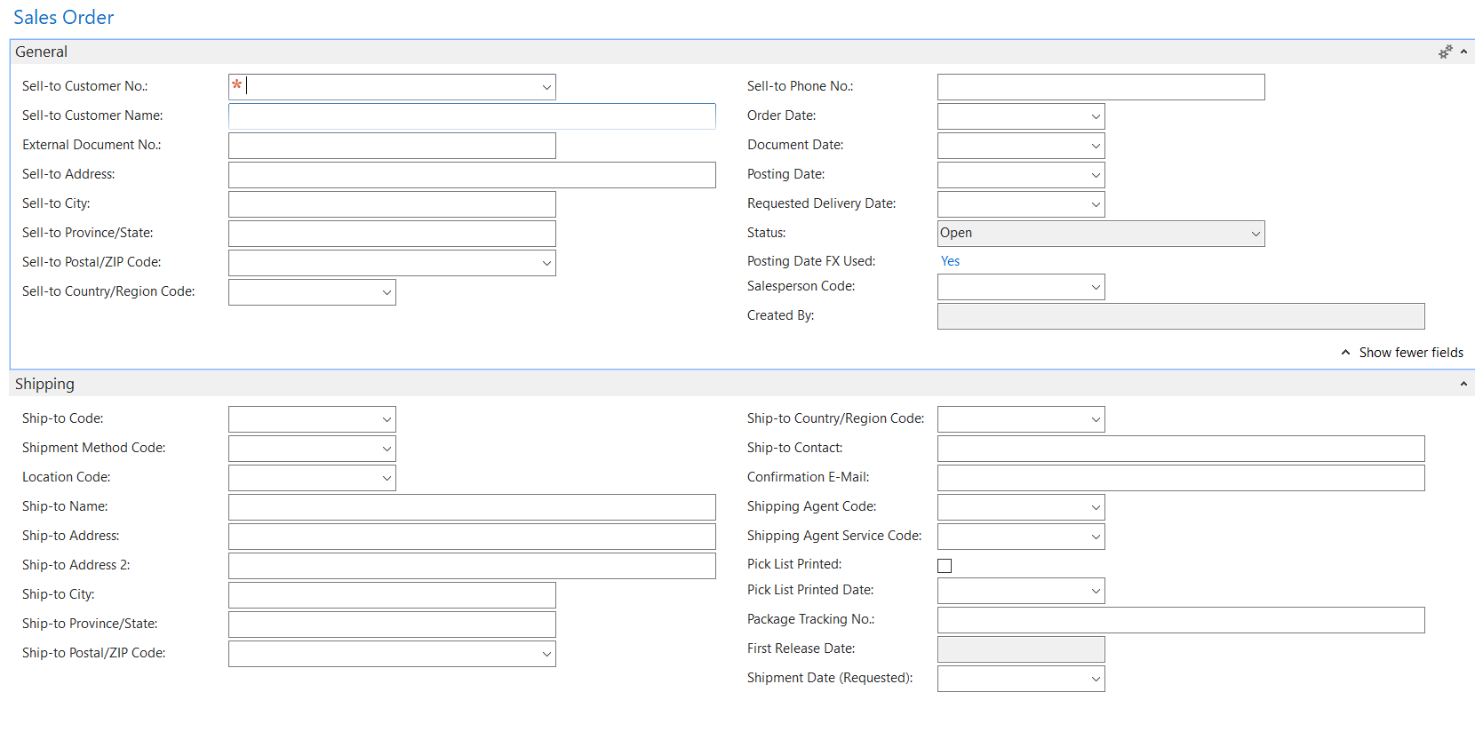

Invoicing: If done properly in Salesforce, all the fields will populate automatically.

Item: Enter TYPE, NO., QTY, add or remove price where appropropriate.

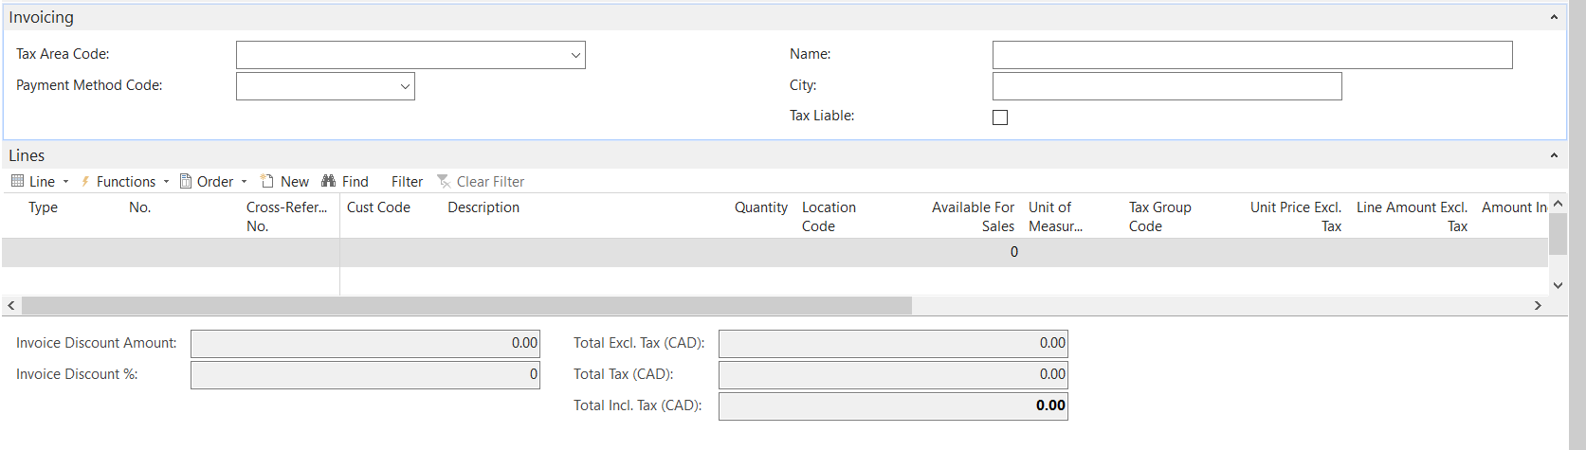

NAV Home Screen Buttons:



Both copy buttons need to be selected at the end of both a sales quote & sales order.

Release button is when you want to release a sales order.

Reopen is when you need to reopen a sales order that has been released.

Print confirmation when you want to save a sales quote or sales order as a PDF to send by email and file.